**Banana Bunchy Top Virus disease and Banana Weevil Surveillance report**

Johnny Masangwa1* and Haswell Dambolachepa2

1*Bvumbwe Agricultural Research Station, Box 5748, Limbe. Email: [masangwajohnny@gmail.com](mailto:masangwajohnny@gmail.com)

2Chitedze Agricultural Research Station, Box 158, Lilongwe. Email: [dambolachepah@yahoo.com](mailto:dambolachepah@yahoo.com)

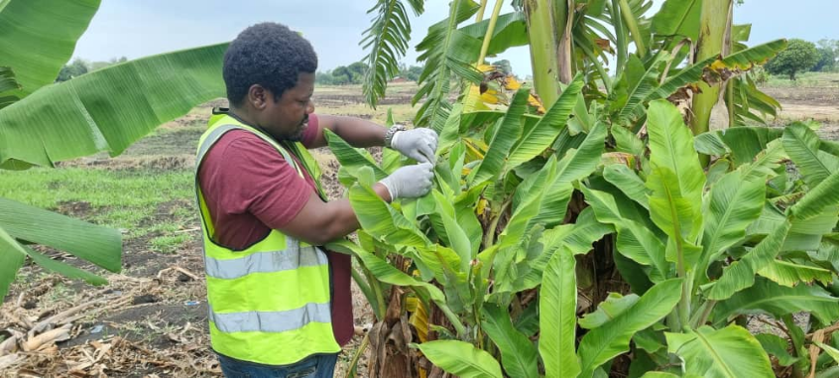

**Abstract**

The country-wide surveillance on BBTV and banana weevil was conducted in November 2023 in 10 major banana growing districts. Sampling sites were at a minimum of 5 km from each other and banana leaf samples, preserved over silica gel. Pseudostem around the mat served as traps and were checked for the presence of banana weevil. Number of weevils caught in each trap was recorded. This study has unveiled that sharing of propagules remain the main source of banana planting materials in Malawi. There is a need of setting up the well-organized banana seed industry whose materials must be certified through molecular virus testing techniques for disease and pest free before the materials are made available to the community. Failure to record banana weevil means that Malawi is either free of this pest or the technique that was employed was not the best one. We therefore, recommend to conduct another survey where different techniques of trapping this pest will be employed to validate the results. Leaf samples collected during this survey have not yet been tested for viruses due to lack of reagents. Reagents need to be procured in order to know the BBTV free areas in the survey areas.

Key words: BBTV, Banana weevil, surveillance, virus testing and banana weevil traps

# Background

Banana (*Musa spp*) is one of the major and important food and cash crops in Malawi. The crop is the major source of carbohydrates, vitamins and minerals. Bananas are ranked sixth in Malawi after maize, rice, groundnuts, vegetables and beans as a food and cash crop [1]. Besides, bananas produce fruits throughout the year and help “bridge” the hunger and income gap between crop harvests [2]. In some parts of the northern region, particularly in Songwe and Misuku hills, banana is an important staple food crop. In general, banana forms an important component in the diets of many Malawians and has been an important food security crop. Economically, banana provides an important source of income for smallholder farmers through direct sales and therefore an important crop for rural livelihood improvement [1]. In Malawi, banana is mostly produced in Thyolo and Mulanje districts in southern region, and Nkhata-bay, Karonga and Chitipa in the northern region. Bananas are also grown in others areas of the country but on a very low scale as in the backyard production mainly for dessert. The crop is estimated to cover an agricultural area of approximately 55,000 hectares with an annual per capita consumption of 28.4 kg per person. Production of banana in Malawi is constrained by pests and diseases such as banana bunchy top disease (BBTD, fusarium wilt, *Fusarium oxysporum* f. sp. *cubense* (Foc) and banana weevil ***(****Cosmopolites sordidus)*.

Banana bunchy top is a viral disease caused by a single-stranded DNA virus called the banana bunchy top virus (BBTV) [3]. Like many viruses, BBTV was named after the symptoms seen, where the infected plants are stunted and have "bunchy" leaves at the top. The disease is transmitted from plant-to-plant in by aphids [4]. Symptoms include deformed plant and stunted appearance. The new leaves that are produced are narrower than normal, yellow, and flat, which causes a “bunchy” appearance at the top of the tree [5]. If any fruit is produced, which is unusual, it will be deformed. In addition, one of the most distinctive symptoms is “Morse code streaking” where the infected cells die and are lighter in color, causing irregular spots and dashes on the leaves that are easier to see when the waxy coating over the petiole is rubbed away.

Banana weevil, *Cosmopolites sordidus* (Germar), commonly known as the banana root borer, banana borer, is a species of weevil in the family Curculionidae. It is considered the most destructive insect pest of bananas. The adult banana root borer is about 11 mm (3⁄8 in) in length and has a glossy greyish-black or dark brown appearance. The larva is plump and whitish with a reddish-brown head. This pest has potential of causing 100% banana corm damage [6].

Occurrence of banana bunchy top disease and banana weevil were reported in Malawi but their recent distribution status has not been studied and documented. Malawi is at great risk because there is extensive sharing of planting materials amongst inhabitants that live and cultivate within border districts, and from one district to another within the country [7]. Hence, the need to conduct pest surveillance.

The aim is to establish the phytosanitary status of a banana in view of emerging pests to enable the National Plant Protection Organization (NPPOs) to have scientific evidence of the incidence, severity and distribution of pests associated with banana in Malawi. The outcome of the surveillance will support decision-making with regard to institution of appropriate control measures.

A national surveillance survey was thus conducted to provide a pathological status of the Banana bunchy top causing pathogen and its distribution in the country. Also, the survey aimed at determining the distribution of banana weevil pest in the country.

# Materials and methods

## *Survey*

A survey was conducted in November 2023 in Thyolo, Mulanje, Blantyre, Ntcheu, Dedza, Nkhotakota, Nkhatabay, Rumphi, Karonga and Chitipa districts. Leaf samples were collected according to Kumar *et al*. [8]. Sampling sites were at a minimum of 5 km from each other. Collected leaves were dried over silica gel.

The conventional split pseudostem traps were used as the already set traps. Leaf sheafs of banana plants were also opened to check for the presence of banana weevil. Number of weevils caught in each trap was recorded.

Farmers were interviewed after seeking consent from them. Interviews and field observation allowed to gather data, that was recorded on the structured questionnaire that was uploaded on KOBOtool.box software [9].

*Map plotting and data analysis*

Data collected during field survey and from the virus indexing were combined, then plotted using ArcMap in ArcGIS 10.5 software [10].

# Results and Discussion

The survey covered three districts in the Southern region, 4 in central and 3 in the northern region of Malawi (Fig 1). The mentioned sites laid within latitude -9.6826249 S to -16.214728 S and longitude 33.2325494 E to 35.7053555 E. The areas’ altitude ranged from 426 to 1622 meters above sea level (masl). A total of 74 people were interviewed of which 52.6 % (n=40) were male banana farmers and 44.7 % (n=37) were female banana farmers (Fig 2). Ninty-eight (98) *Musa* leaf samples were collected from 22 known cultivars and 1 unknown cultivar. The results showed that Willians and Zanda registered high leaf samples 28.6 % (n=28) and 25.5 %, respectively while other cultivars recorded 4.1 % and below (Table 1).

Sharing of banana propagules remain the primary source of banana mat and it accounted 57 % (n=43) followed by 28 % (n=21) for purchase and the remaining proportion 15 % (n=10) comprised of government, NGO, Own field and others as sources of banana mats. Within the source category others, flooding water was mentioned as a source banana mat. Farmers need to be sensitized of the danger associated with this source. The results of this study agree with the findings of Masangwa [7] who found sharing of planting material as a main source of banana mat and also flooding as another source of the same. Our findings also concur with Mulugo *et al*. [11], who reported that in the Sub Sahara region, farmers prefer the informal seed system to the extent that more than 90% of farmers in the banana farming systems in Africa rely on suckers sourced from friends, neighbours, relatives and/or their own fields to establish new banana gardens. This scenario of banana planting material sharing among relatives is also supported by other studies [12, 13, 14] which reported this source as prominent in other African countries. Our results unveiled the consequence of the absence of the official banana seed system in Malawi. There is low availability of virus indexed propagules in Malawi which encourages sharing and poses a risk of spreading viruses.

Farmers’ knowledge of banana diseases was investigated during the study and the results showed that 56% (n=42) of Malawi’s farmers were aware of banana diseases while 44% were not (Fig 4). BBTV was the disease that was known by 46% of banana farmers and very few farmers are aware of other diseases such as banana *Fusarium* wilt and banana bacterial wilt (Fig 5).

The study did not record banana weevil this could mean that they are no banana weevil in Malawi or that the searching of this pest using the already cut pseudostem as bait was not a best technique to be employed when conducting banana weevil survey.

Aphids were the prominent insect pests that was present in the banana orchards (13.5%) and it is also known by farmers. Mealybug was found in 1.4% of total mats that were sampled. This study did not find any banana weevil and farmers indicated the ignorance of the mentioned pest. The high incidences of aphids are correlated to high prevalence of BBTV disease in survey area. Banana viral diseases are transmitted by vectors such as aphids (*Pentalonia nigronervosa* Coquerel and *Pentalonia caladii* van der Goot.) for BBTV [4], aphids (*Pentalonia nigronervosa)* for BBrMV [15], mealybugs (*Saccharicoccus sacchari* (Sugarcane mealybug), *Planococcus citri* (Citrus mealybug), Oleander mealybug and *Dysmicoccus brevipes* (pine apple mealybug) for BSVs [16; 17]. The Banana bunchy top disease was officially reported in Malawi and was responsible for the loss of banana plantation in southern region of Malawi. Banana streak virus is not officially reported to be present and BBrMV is absent in Malawi.

**Conclusion and recommendations**

The primary source of banana planting materials is sharing which could be a source behind the spread of virus diseases. There is a need of setting up the well-organized banana seed industry whose materials must be certified of being disease and pest free before the materials are made available to the community. Failure to record banana weevil means that Malawi is either free of this pest or the technique that was employed was not the best one. We therefore, recommend to conduct another survey where different techniques of trapping this pest will be employed to validate the results. Leaf samples collected during this survey have not yet been tested for viruses due to lack of reagents. Reagents need to be procured in order to know the BBTV free areas in the survey areas.

Acknowledgements

We would like to extend profound vote of thanks to FAO Malawi through One Country and On Priority Product (OCOPP) for the financial support toward the survey. We would also like to extend our gratitude to the following DARS technical team: Ms. Kopa, Mr. F. Mabedi, Mr. M. Mpemba, Mr. Z. Langisi and Mr. R. Banda for their technical assistance during the surveillance exercise. Lastly, we greatly acknowledge the noble work of plotting survey by Mr. P. Moses of DAPP Malawi.

Reference

1. Gondwe, W.T. and Banda, D.L.N. 2002. Banana Baseline Survey in Malawi. Ministry of Agriculture and Irrigation, Bvumbwe Agricultural Research Station.
2. Karamura E., Workshop objectives, in: Mobilizing IPM for sustainable banana production in Africa, Proc. workshop on banana IPM held in Nelspruit, South Africa, 23–28 November 1998, INIBAP, Montpellier, France, 1999.
3. [Harding](https://pubmed.ncbi.nlm.nih.gov/?term=Harding+RM&cauthor_id=1993864) RM, [Burns](https://pubmed.ncbi.nlm.nih.gov/?term=Burns+TM&cauthor_id=1993864) TM, [Dale](https://pubmed.ncbi.nlm.nih.gov/?term=Dale+JL&cauthor_id=1993864) JL. Virus-like particles associated with banana bunchy top disease contain small single-stranded DNA. J Gen Virol 1991; 72(2):225-30. Doi: 10.1099/0022-1317-72-2-225.
4. Watanabe S, Greenwell AM, Bressan A. Localization, concentration and transmission efficiency of banana bunchy top virus in four asexual lineages of Pentalonia aphids. Virus 2013; 5(2): 758-776. Doi:10.3390/v5020758.
5. Nelson SC. Banana bunchy top: Detailed signs and symptoms. UH-CTAHR Cooperative Extension Service 2004. <https://www.ctahr.hawaii.edu/bbtd/downloads/bbtv-details.pdf>. Accessed on 26 January 2024.
6. Twesigye, C.K., Ssekatawa, K., Kiggundu, A. *et al.* Corm damage caused by banana weevils *Cosmopolites sordidus* (Germar) collected from different banana growing regions in Uganda. Agric & Food Secur 2018; **7**: 73. <https://doi.org/10.1186/s40066-018-0224-y>
7. Masangwa JIG. Banana viruses survey in Malawi. Unpublished 2020
8. Kumar PL, Hanna R, Alabi OJ, Soko MM, Oben TT, Vangu GHP, Naidu RA. Banana bunchy top virus in sub-Saharan Africa: Investigations on virus distribution and diversity. Virus Res. 2011; 159: 171 – 182.
9. KoboToolbox. htts//support.kobotoolbox.org
10. Sreejit SN, Tech M, Katiyar SK. Web enabled open source GIS based tourist information system for Bhopal city. Int. J. Eng. Sci. Technol 2011; 3: 1457-1466.
11. Mulugo L, Kyazze FG, Kibwika P, Kikulwe E, Omondi AB, Ajambo S. (2019) Unravelling technology-acceptance factors influencing farmer use of banana tissue culture planting materials in Central Uganda. African J. Sci. Technol. Innov. Dev. 2019; 12(4): 453-465, DOI: 10.1080/20421338.2019.1634900
12. Nduwimana I, Sylla, S, Xing Y, Simbare, A, Niyongere, C, Garrett KA Omondi AB. Banana seed exchange networks in Burundi – Linking formal and informal systems. Outlook Agric. 2022; 51(3): 334-348 <https://doi.org/10.1177/00307270221103288>
13. Nkengla-Asi L; Eforuoku F; Olaosebikan O, Ladigbolu AT, Amah D, Hanna R, Kumar PL. Gender roles in sourcing and sharing of banana planting material in communities with and without banana bunchy top disease in Nigeria. Sustainability 2021; 13: 3310. https://doi.org/10.3390/ su13063310.
14. Simbare A, Sane CAB, Nduwimana I, Niyongere C, Omondi, BA. Diminishing Farm Diversity of East African highland bananas in banana bunchy top disease outbreak areas of Burundi—The effect of both disease and control approaches. Sustainability2020; 12(18): 7467. <https://doi.org/10.3390/su12187467>.
15. Madhavan S, Balasubramanian V, Ramajayam D. *et al.* Occurrence of *Banana bract mosaic virus* on *Musa ornata* Roxb based hybrids in India. Virus Dis.2022; 33: 397–403. <https://doi.org/10.1007/s13337-022-00788-6>
16. Abdel-Salam SM, Dahot MU, Sadik SA. Molecular comparative analysis of component 1 (DNA-R) of an Egyptian isolate of banana bunchy top nanovirus isolated from banana aphid. Journal of Genetic Engineering and Biotechnology 2012; 10: 55-65.
17. Muturi SM, Wachira FN, Karanja LS, Njeru SM. The mode of transmission of banana streak virus by *Paracoccus burnerae* (Homiptera; Planococcidae) vector is non-circulative. Br. Microbio.l Res. J. 2016; 12(6): 1-10.

Appendex

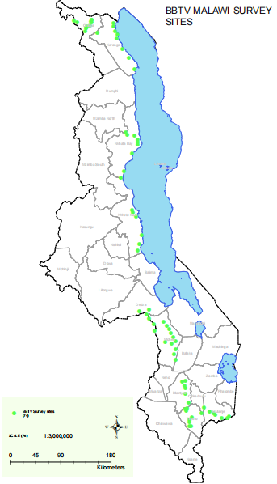

Figure 1. Survey sites

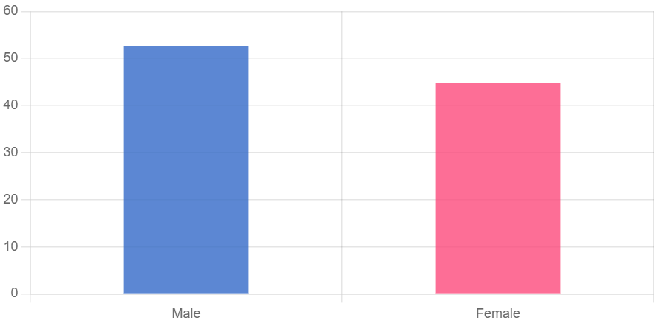

Figure 2. Correspondents desegregated into gender.

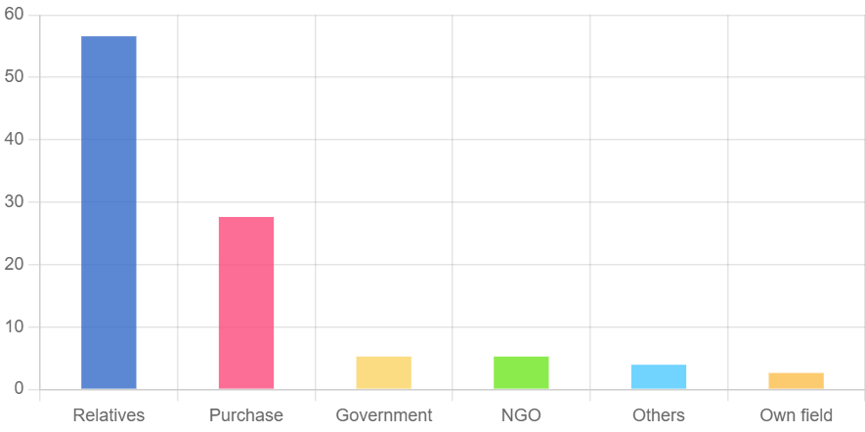

Figure 3. Source of banana mat

Table 1. Banana cultivar, number of samples and percent

|  |  |  |
| --- | --- | --- |
| **Variety name** | **Number of samples** | **% of total sample collected** |
| Bindika | 1 | 1.0% |
| Harare | 1 | 1.0% |
| Kaluma | 1 | 1.0% |
| Kamaganda | 1 | 1.0% |
| Katsizi | 4 | 4.1% |
| Khazanga | 1 | 1.0% |
| Kabuthu | 2 | 2.0% |
| Kalaghasya | 1 | 1.0% |
| Katerera | 2 | 2.0% |
| Kenya | 1 | 1.0% |
| Kholobowa | 4 | 4.1% |
| Mulanje | 9 | 9.2% |
| Ndoki | 3 | 3.1% |
| Nyangayagwape | 1 | 1.0% |
| Pama | 2 | 2.0% |
| Sukali | 4 | 4.1% |
| Swershi | 3 | 3.1% |
| Tondama | 1 | 1.0% |
| Uganda | 1 | 1.0% |
| Unknown | 1 | 1.0% |
| Williams | 28 | 28.6% |
| Zanda | 25 | 25.5% |
| Zomba red | 1 | 1.0% |
| **Total** | **98** | **100.0** |

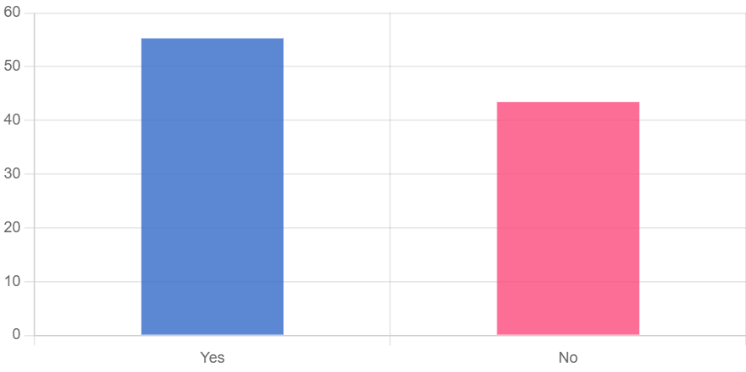

Figure 4. Farmers’ banana disease knowledge

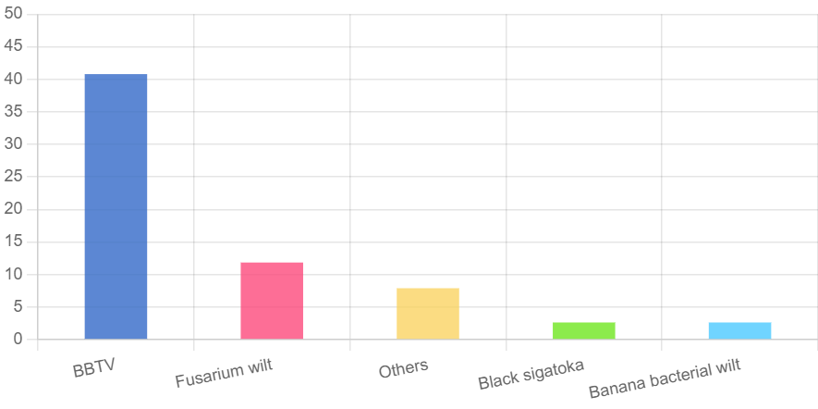

Figure 5. Diseases known by farmers

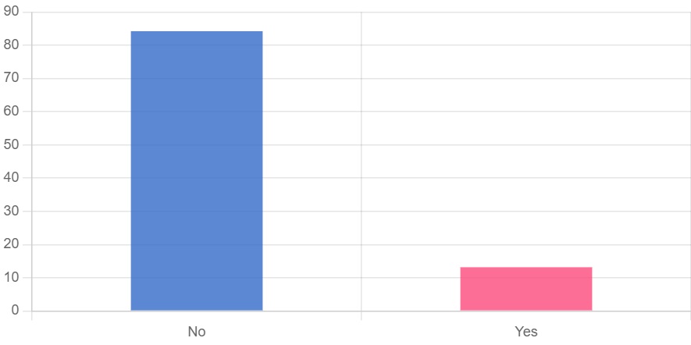

Figure 6. Farmers’ insect pest awareness

Table 2. Pests infestation in banana orchards

|  |  |  |  |
| --- | --- | --- | --- |
| **Name of pest** | **Number of infested orchards** | **% of total infested banana orchard** | **% of the total samples** |
| Aphids | 10 | 76.9 | 13.5 |
| Mealybug | 1 | 7.7 | 1.4 |
| Banana weevil | 0 | 0 | 0 |
| Millipeds | 1 | 7.7 | 1.4 |
| Unknown pests | 1 | 7.7 | 1.4 |
| **Total** | **13** | **100** | **17.7 %** |