

TOMATO LATE BLIGHT DISEASE (Phytophthora infestans)
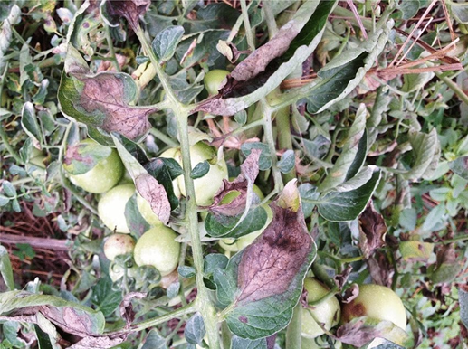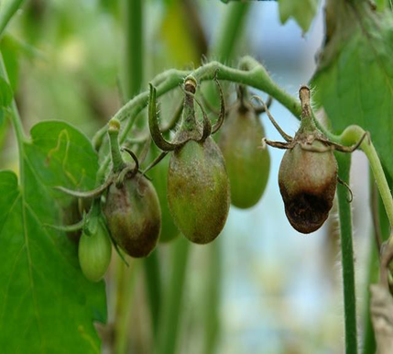
Late Blight on tomato leavesª and fruits^{b}
ª© DARS , ^{b} © CABI/Plantwise

Late blight is a serious disease that mostly attacks tomato plants and other crops in the same family such as pepper, eggplant, and potato.
The symptoms of the disease appear on leaves, stems, and fruits. The disease causes many tomato leaves to fall off, which reduces yield.

SYMPTOMS ON TOMATO LEAVES

- Pale green to brownish-black water-soaked leaf spots with rapid growth covering large areas of the leaf.
- Leaf spot on the underneath may be covered with a gray to white moldy growth (easily confused with powdery mildew disease).
- Larger spot, a ring of moldy growth that appear during humid weather.
- The foliage turns yellow and then brown, curls, shrivels, and eventually dies.

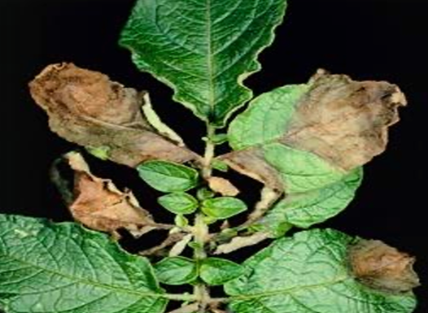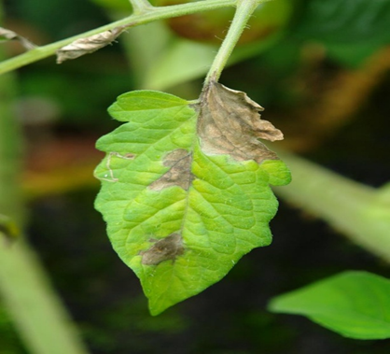
Tomato leaves showing signs of late blight ª© DARS, ^{b} © CABI/Plantwise

SYMPTOMS ON TOMATO PETIOLES AND STEMS
- Brown to black water-soaked spots that cover large areas of the petioles and stems.
- Spots are covered with gray to whitish powder.
- Death of stems and petioles leading to death of the plant.

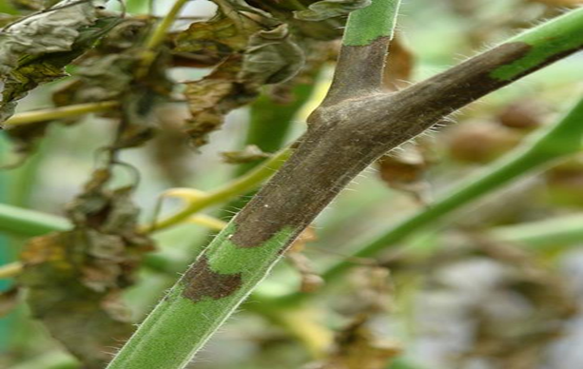
Brown lessions on tomato stem © CABI/Plantwise

SYMPTOMS ON TOMATO FRUITS

- Dark yellowing green greasy spots develop on green fruit.
- Sunken lesions with concentric rings of variable sizes form on fruit near the calyx or stem ends
- A thin layer of whitish powder may be present during wet weather.
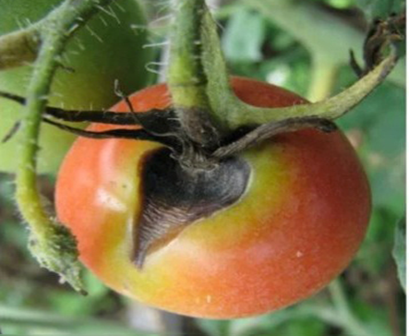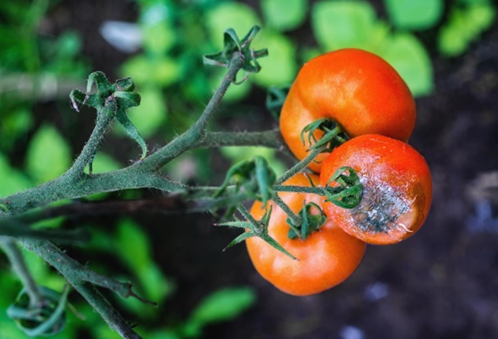
Dark spot-on tomato fruit
Whitish powder
Late blight on tomato fruits © DARSª © gartenjournal^{b}

HOW THE DISEASE SPREADS

- Late blight enters tomato plants through leaf openings and multiply, damaging stems, leaves, and fruits.
- The disease spreads in the field when carried by wind, rainwater, and irrigation, and it can survive for a long time in plants and crop residues.
- The disease spreads most in hot areas and in places where rainfall is high.

TOMATO LATE BLIGHT DISEASE CONTROL MEASURES

- Inspect the plants regularly for late blight disease symptom
- Grow tomatoes in glasshouses or in spaces where there is humidity control and the plants are covered and protected from rainfall.
- Stake up tomato plants, to keep tomato stems and branches away from the ground.
- Use wide plant spacing to allow air ventilation of the tomato canopy, which allows wet plant surfaces to dry off most rapidly.
- Use disease-free tomato transplants.
- Destroy volunteer tomato plants.
- Avoid moving through the tomato garden or field when plant foliage is wet.
- Rotate crops; avoid successive crops of tomatoes in the same location; avoid planting a new crop of tomatoes beside a diseased crop.
- Do not plant potatoes near tomatoes, or if potatoes are planted, use a blight-resistant variety.
- Time irrigation to water plants early in the day, rather than late in the day.
- Control solanaceous weeds around the tomato garden.
- Protect seedlings with fungicide sprays before transplanting (consult).

For more information, contact your nearest agriculture extension office

Malawi
Created/Edited on October 17, 2025
©MINISTRY OF AGRICULTURE, MADIPHS PROJECT
CC BY-NC-SA 4.0 LICENSE

